L2 Support

L1 Support assigned the service call to l2

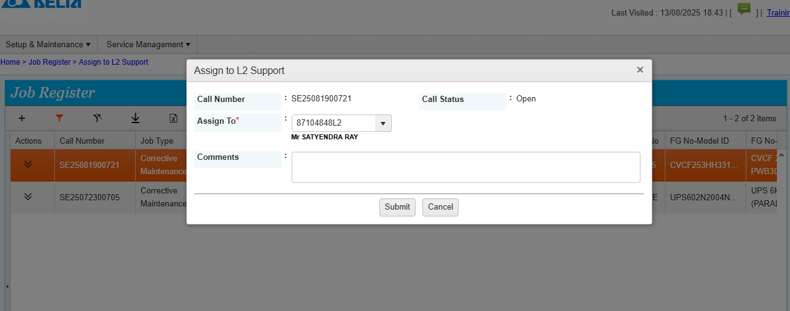

L2 Support do the following steps

URL- <https://mcis.deltaiserve.net/>

1)Type the URL , enter the login credential and do the login

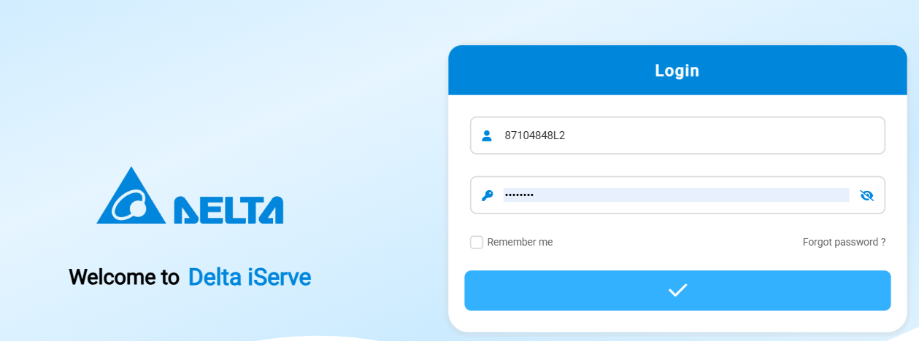2) Go to job register and see the assigned calls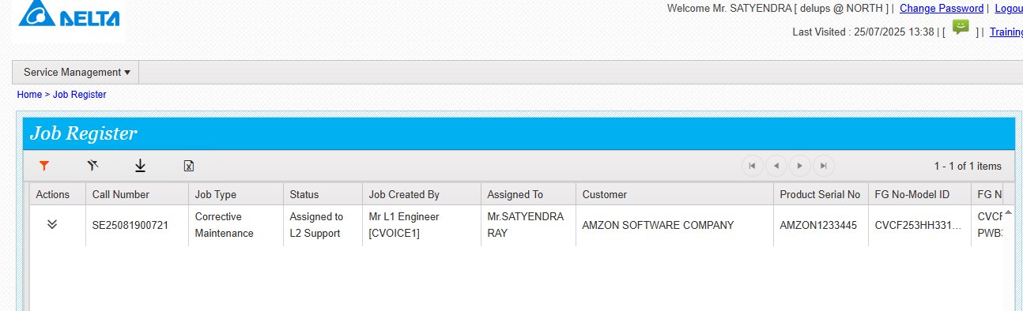

Click on action button and see the options available

L2 support can do edit , close , assigned to onsite support.

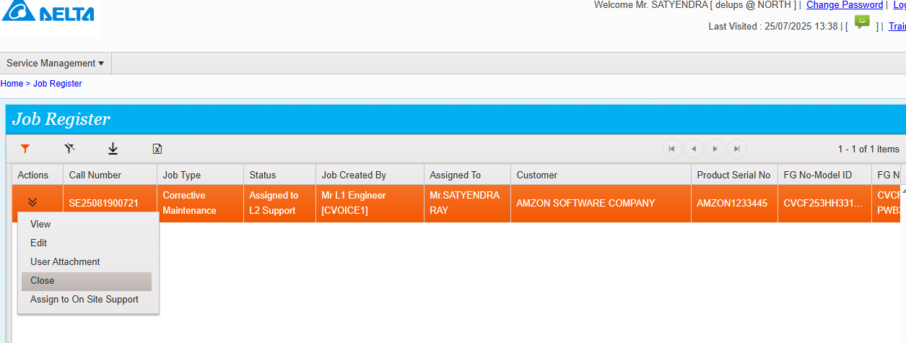

If edit button is clicked then l2 support can add the parts in parts recommended tab

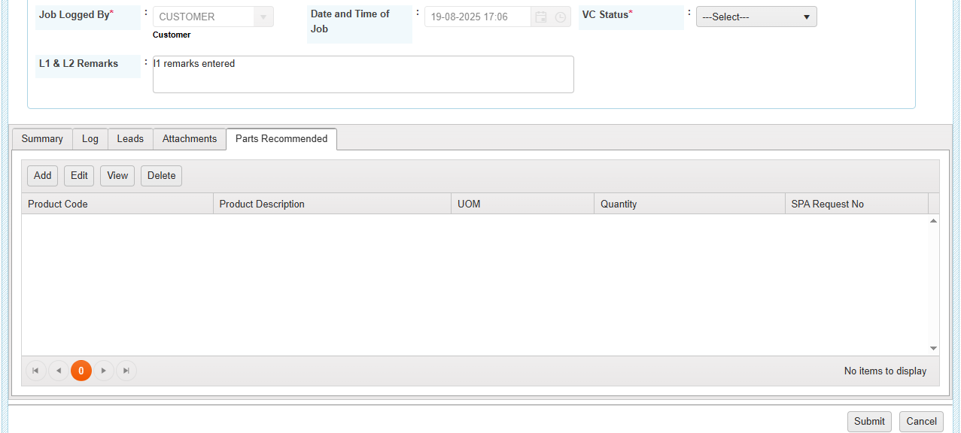

Update the VC status , add the parts then submit.

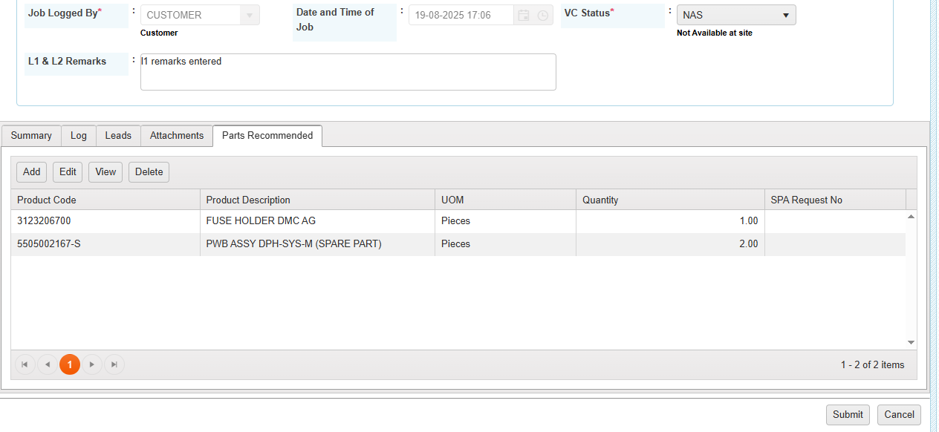

Details saved successfully.

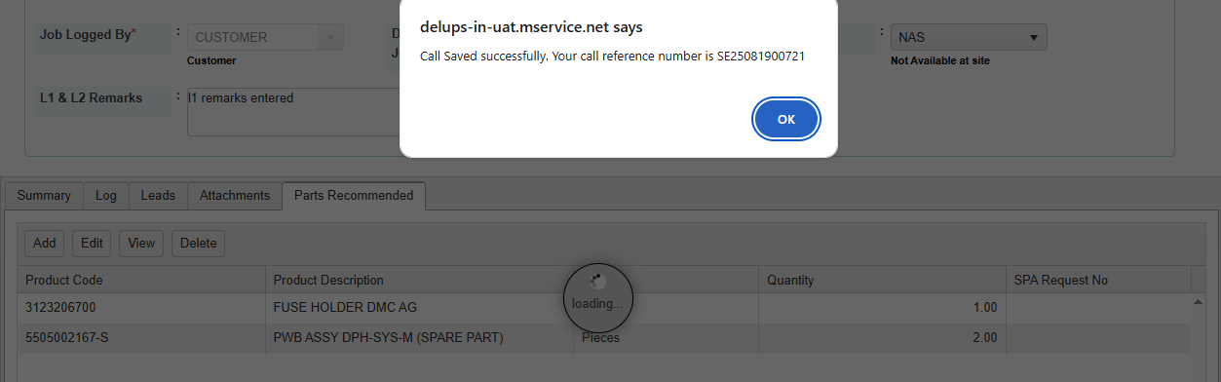

Click on on site support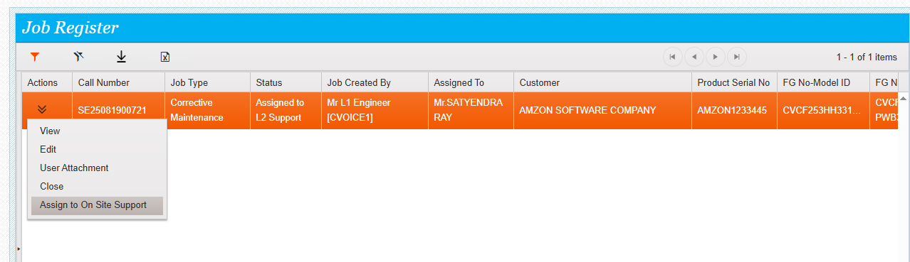

System will show the parts coordinator details . once submit button is clicked then the service call will be assigned to the respective mapped parts coordinator.

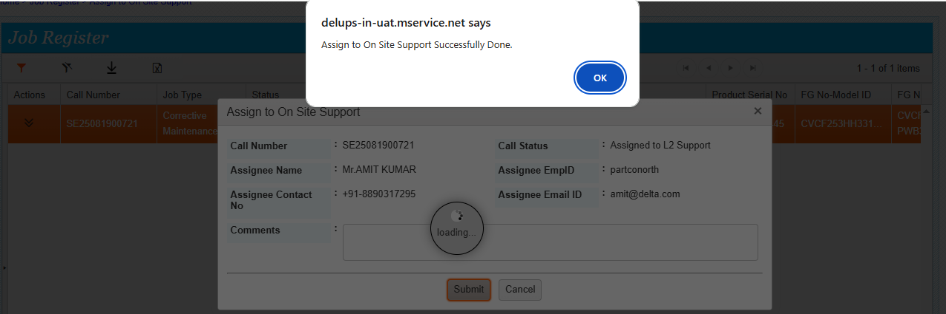

Assigned to onsite support done successfully,

